Pumpkin or Squash Purees

Eat your orange vegetables now and in the off season by using canned and frozen varieties. These vegetables are a staple for anyone living from the garden or farm because they are easy to grow, full of nutrition, very filling, last a long time at room temperature and are easy to freeze. Many varieties of squash or pumpkin can be used for warm, fall and winter dishes or frozen to use in the early spring in grain salads and baked goods while waiting for the new year’s growth. We’ll be cooking a Curried Pumpkin Soup in class but you’ll bring home inspiration for other dishes as well.

Tips:
- Most winter squash and pumpkins can be used in recipes interchangably. They will differ a little in sweetness and water content.
- Roasting (see below) brings out natural sweetness.
- Puree or mash right away or mid-recipe with any tool available!
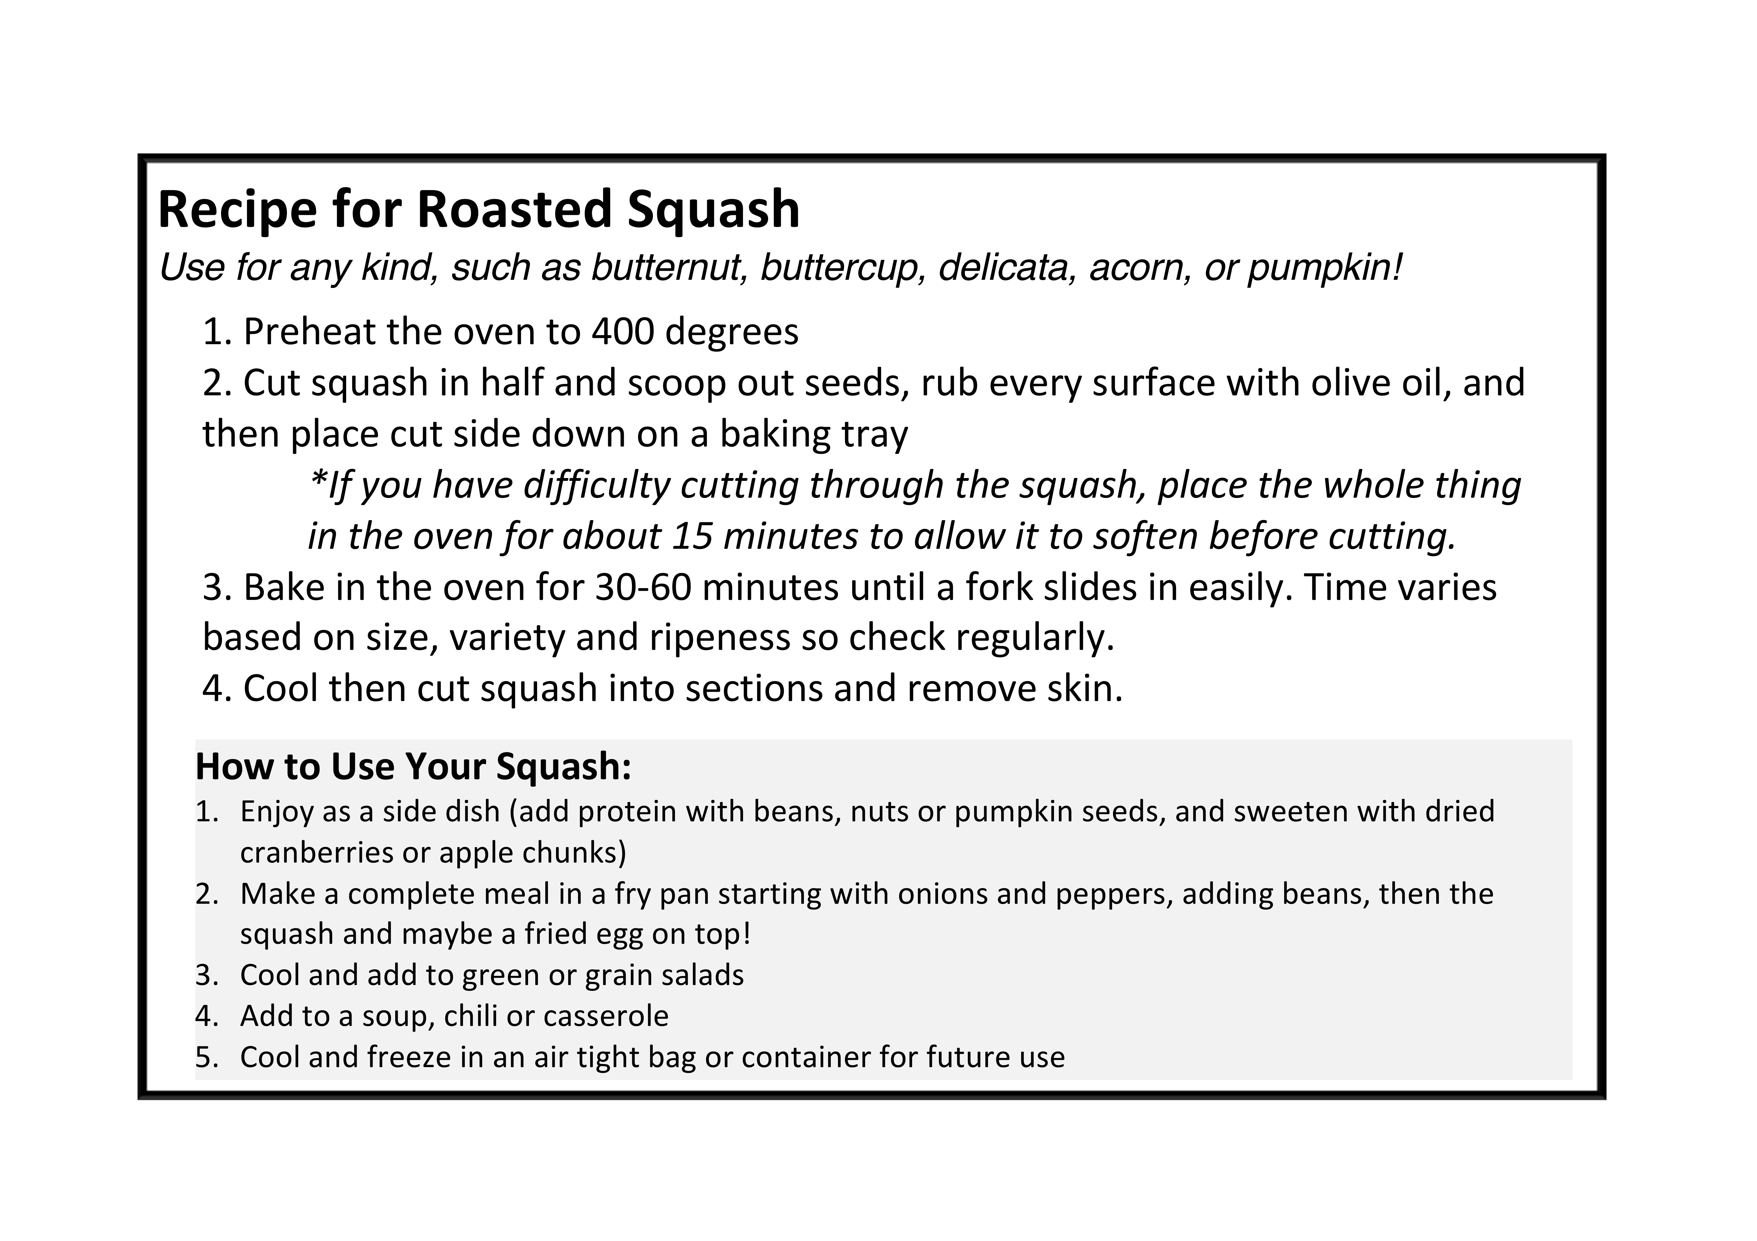
Adjust the following recipe to your tastes!
- Substitute roasted or frozen squash for canned pumpkin (a can is 15 oz or 1 3/4 c fresh)
- Substitute curry powder and nutmeg for paprika OR cumin and coriander OR cinnamon and cloves OR turmeric
- Substitute heavy cream instead of evaporated milk
- Add some apples or applesauce for natural sweetness
- Add chopped leafy greens in the last 3 minutes, such as kale, chard or spinach
- Add chickpeas after puree for a complete meal. Pour over rice to make even more filling.

